**Full stack**

Production Level CICD Pipeline Project

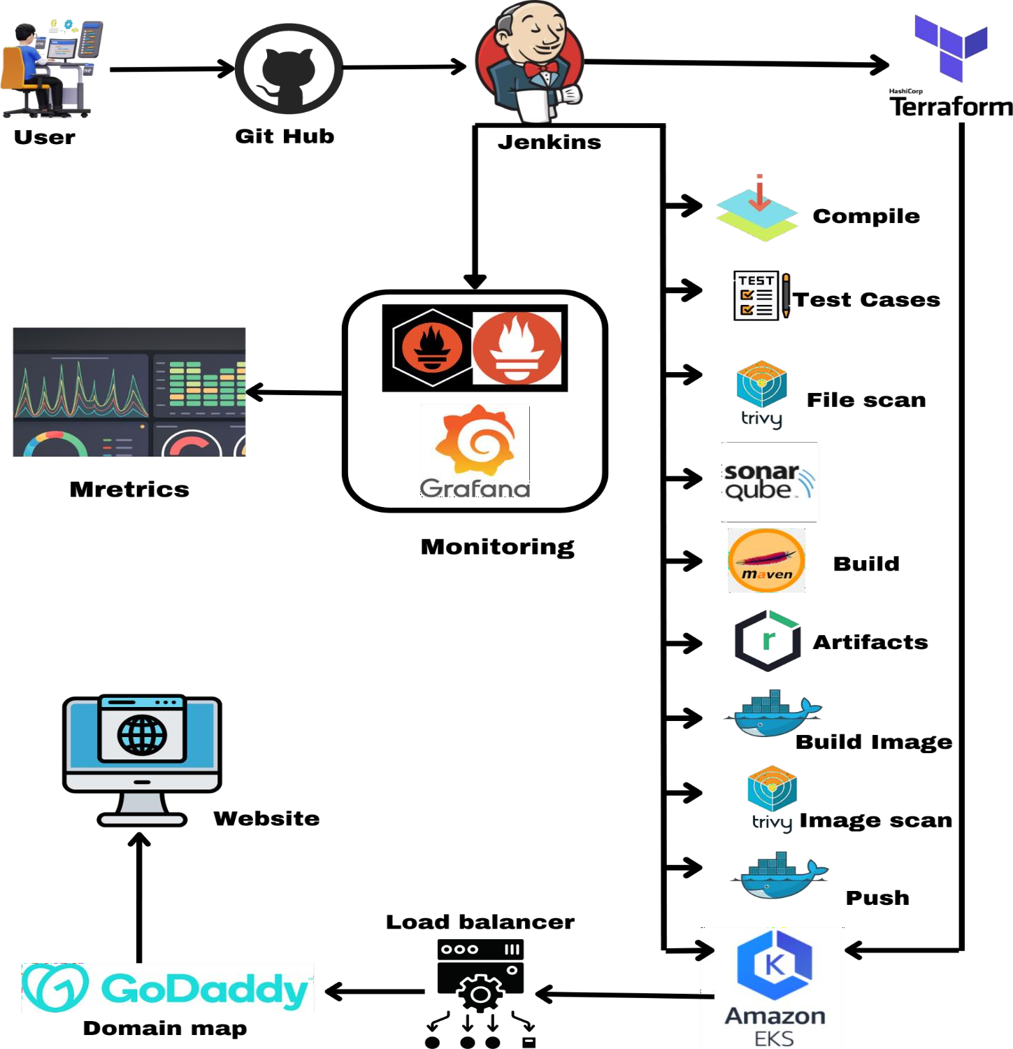

## Introduction

In the modern software development landscape, Continuous Integration and Continuous Deployment (CI/CD) pipelines are critical for ensuring that code changes are automatically built, tested, and deployed to production environments in a consistent and reliable manner. This document provides a comprehensive guide to setting up a robust CI/CD pipeline using various tools hosted on AWS EC2 instances. The process will cover everything from setting up the necessary infrastructure to deploying an application on an Amazon EKS (Elastic Kubernetes Service) cluster, assigning a custom domain, and monitoring the application to ensure its stability and performance.

The pipeline will incorporate several industry-standard tools:

**AWS** : Creating virtual machines .

**Jenkins** for automating the build, test, and deployment processes.

**SonarQube** for static code analysis to ensure code quality.

**Trivy** file scan to scan files and vulnerability scanning for Docker images.

**Nexus** Repository Manager for managing artifacts. **Terraform** as infrastructure as code to create EKS Cluster. **Docker**: Containerization for consistency and portability. **Kubernetes**: Container orchestration for deployment.

**Prometheus and Grafana** for monitoring the pipeline and application performance.

By following this guide, you'll be able to set up a fully functional CI/CD pipeline that supports continuous delivery and helps maintain high standards for code quality and application performance.

### Step 1 : Set Up GitHub Repository and Push Local Code

Create a New GitHub Repository:

1. Login to GitHub:
   * Visit GitHub and log in to your account.
2. Create a New Repository:
   * Click on the "+" icon in the top-right corner and select "New repository."
   * Repository Name: Enter a name for your repository (e.g., `my-ci-cd- project`).
   * Description: (Optional) Add a brief description of your project.
   * Visibility: Choose between Public or Private.
   * Initialize Repository:

- You can choose to add a README file, `.gitignore` file, and select a license, or leave these options unchecked if you're pushing an existing project.

1. Click on "Create repository.”

2.2 Push Existing Local Code to GitHub:

1. Initialize Git in Your Local Project:
   * Open your terminal or command prompt.
   * Navigate to your project directory:

cd /path/to/your/project

* + Initialize Git:

git init

1. Add Remote Repository:
   * Add your GitHub repository as a remote:

git remote add origin https://github.com/your-username/my-ci-cd- project.git

* + Replace `your-username` and `my-ci-cd-project` with your GitHub username and repository name.

1. Add and Commit Your Code:
   * Stage all changes:

git add .

* + Commit the changes:

git commit -m "Initial commit"

1. Push to GitHub:
   * Push your code to the `main` branch:

git push -u origin main

Repository Link

Repository URL Add your GitHub repository link here: https://github.com/jaiswaladi246/FullStack-Blogging-App.git

### Step 2. Launch Virtual Machine for Jenkins, Sonarqube and Nexus

Here is a detailed list of the basic requirements and setup for the EC2 instance i have used for running Jenkins, including the specifics of the instance type, AMI, and security groups.

EC2 Instance Requirements and Setup:

#### Instance Type

* + Instance Type: `t2.large`
    - vCPUs: 2
    - Memory: 8 GB
    - Network Performance: Moderate

#### Amazon Machine Image (AMI)

* + AMI: Ubuntu Server 20.04 LTS (Focal Fossa)

#### Security Groups

Security groups act as a virtual firewall for your instance to control inbound and outbound traffic.

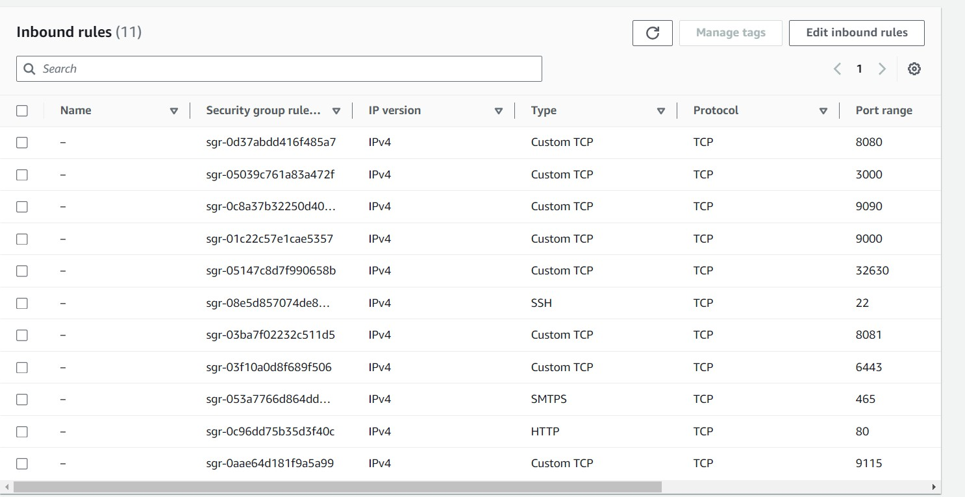

After Launching your Virtual machine ,**SSH** into the Server.

## Step3. Installing Jenkins on Ubuntu

Execute these commands on Jenkins Server #!/bin/bash

# Install OpenJDK 17 JRE Headless

sudo apt install openjdk-17-jre-headless -y # Download Jenkins GPG key

sudo wget -O /usr/share/keyrings/jenkins-keyring.asc \ https://pkg.jenkins.io/debian-stable/jenkins.io-2023.key # Add Jenkins repository to package manager sources

echo deb [signed-by=/usr/share/keyrings/jenkins-keyring.asc] \ https://pkg.jenkins.io/debian-stable binary/ | sudo tee \

/etc/apt/sources.list.d/jenkins.list > /dev/null # Update package manager repositories sudo apt-get update

# Install Jenkins

sudo apt-get install jenkins -y

Save this script in a file, for example, install_jenkins.sh, and make it executable using:

chmod +x install_jenkins.sh

Then, you can run the script using:

./install_jenkins.sh

This script will automate the installation process of OpenJDK 17 JRE Headless and Jenkins.

### Install docker for future use

Execute these commands on Jenkins, SonarQube and Nexus Servers

#!/bin/bash

# Update package manager repositories sudo apt-get update

# Install necessary dependencies

sudo apt-get install -y ca-certificates curl # Create directory for Docker GPG key sudo install -m 0755 -d /etc/apt/keyrings # Download Docker's GPG key

sudo curl -fsSL https://download.docker.com/linux/ubuntu/gpg -o

/etc/apt/keyrings/docker.asc

# Ensure proper permissions for the key sudo chmod a+r /etc/apt/keyrings/docker.asc # Add Docker repository to Apt sources

echo "deb [arch=$(dpkg --print-architecture) signed by=/etc/apt/keyrings/docker.asc] https://download.docker.com/linux/ubuntu

\

$(. /etc/os-release && echo "$VERSION_CODENAME") stable" | \ sudo tee /etc/apt/sources.list.d/docker.list > /dev/null

# Update package manager repositories sudo apt-get update

sudo apt-get install -y docker-ce docker-ce-cli containerd.io docker-buildx- plugin

docker-compose-plugin

Save this script in a file, for example, install_docker.sh, and make it executable using:

chmod +x install_docker.sh

Then, you can run the script using:

./install_docker.sh

### SetUp Nexus

Execute these commands on Nexues VM

#!/bin/bash

# Update package manager repositories sudo apt-get update

# Install necessary dependencies

sudo apt-get install -y ca-certificates curl # Create directory for Docker GPG key sudo install -m 0755 -d /etc/apt/keyrings # Download Docker's GPG key

sudo curl -fsSL https://download.docker.com/linux/ubuntu/gpg -o

/etc/apt/keyrings/docker.asc

# Ensure proper permissions for the key sudo chmod a+r /etc/apt/keyrings/docker.asc # Add Docker repository to Apt sources

echo "deb [arch=$(dpkg --print-architecture) signed by=/etc/apt/keyrings/docker.asc] https://download.docker.com/linux/ubuntu

\

$(. /etc/os-release && echo "$VERSION_CODENAME") stable" | \ sudo tee /etc/apt/sources.list.d/docker.list > /dev/null

# Update package manager repositories sudo apt-get update

sudo apt-get install -y docker-ce docker-ce-cli containerd.io docker-buildx- plugin

docker-compose-plugin

Save this script in a file, for example, install_docker.sh, and make it executable using:

chmod +x install_docker.sh

Then, you can run the script using:

./install_docker.sh

## Create Nexus using docker container

To create a Docker container running Nexus 3 and exposing it on port 8081, you can

use the following command:

docker run -d --name nexus -p 8081:8081 sonatype/nexus3:latest This command does the following:

* -d: Detaches the container and runs it in the background.
* --name nexus: Specifies the name of the container as "nexus".
* -p 8081:8081: Maps port 8081 on the host to port 8081 on the container, allowing

access to Nexus through port 8081.

* sonatype/nexus3:latest: Specifies the Docker image to use for the container,

in this

case, the latest version of Nexus 3 from the Sonatype repository.

After running this command, Nexus will be accessible on your host machine at http://IP:8081.

Get Nexus initial password

Your provided commands are correct for accessing the Nexus password stored in the

container. Here's a breakdown of the steps:

1. **Get Container ID**: You need to find out the ID of the Nexus container. You can do this by running:

docker ps

This command lists all running containers along with their IDs, among other information.

1. **Access Container's Bash Shell**: Once you have the container ID, you can execute the docker exec command to access the container's bash shell: docker exec -it <container_ID> /bin/bash

Replace **<container_ID>** with the actual ID of the Nexus container.

1. **Navigate to Nexus Directory**: Inside the container's bash shell, navigate to the directory where Nexus stores its configuration:

cd sonatype-work/nexus3

1. **View Admin Password**: Finally, you can view the admin password by displaying the contents of the admin.password file:

cat admin.password

1. **Exit the Container Shell**: Once you have retrieved the password, you can exit the container's bash shell:

exit

This process allows you to access the Nexus admin password stored within the container.

## SetUp SonarQube

### Execute these commands on SonarQube VM

#!/bin/bash

# Update package manager repositories sudo apt-get update

# Install necessary dependencies

sudo apt-get install -y ca-certificates curl # Create directory for Docker GPG key sudo install -m 0755 -d /etc/apt/keyrings # Download Docker's GPG key

sudo curl -fsSL https://download.docker.com/linux/ubuntu/gpg -o

/etc/apt/keyrings/docker.asc

# Ensure proper permissions for the key sudo chmod a+r /etc/apt/keyrings/docker.asc # Add Docker repository to Apt sources

echo "deb [arch=$(dpkg --print-architecture) signed by=/etc/apt/keyrings/docker.asc] https://download.docker.com/linux/ubuntu

\

$(. /etc/os-release && echo "$VERSION_CODENAME") stable" | \ sudo tee /etc/apt/sources.list.d/docker.list > /dev/null

# Update package manager repositories sudo apt-get update

sudo apt-get install -y docker-ce docker-ce-cli containerd.io docker-buildx- plugin

docker-compose-plugin

Save this script in a file, for example, install_docker.sh, and make it executable using:

chmod +x install_docker.sh

Then, you can run the script using:

./install_docker.sh

### Create Sonarqube Docker container

To run SonarQube in a Docker container with the provided command, you can follow

these steps:

1. Open your terminal or command prompt.
2. Run the following command:

docker run -d --name sonar -p 9000:9000 sonarqube:lts-community

This command will download the sonarqube:lts-community Docker image from Docker

Hub if it's not already available locally. Then, it will create a container named "sonar"

from this image, running it in detached mode (-d flag) and mapping port 9000 on the

host machine to port 9000 in the container (-p 9000:9000 flag).

1. Access SonarQube by opening a web browser and navigating to http://VmIP:9000.

This will start the SonarQube server, and you should be able to access it using the

provided URL. If you're running Docker on a remote server or a different port, replace localhost with the appropriate hostname or IP address and adjust the port

accordingly.

# Step 4 .Install and Configur Plugins on Jenkins

## Plugins:

* 1. SonarQube Scanner
  2. Config file provider
  3. Maven Integration
  4. Pipeline maven integration.
  5. Kubernetes
  6. Kubernetes Client API
  7. Kubernetes Credentials
  8. Kubernetes CLI
  9. Docker
  10. Docker Pipeline
  11. Pipeline Stage View
  12. Eclipse Temurin Installer

## Plugin Configuration –> Check Video

You need to create credentials for Docker and GitHub access.

#### Create Docker Credentials:

-Go to Manage Jenkins > Manage Credentials > (global) > Add Credentials.

-Choose Username with password as the kind.

-ID: docker-cred

-Username: Your Docker Hub username.

-Password: Your Docker Hub password.

-Click OK.

#### Create GitHub Credentials:

-Go to Manage Jenkins > Manage Credentials > (global) > Add Credentials.

-Choose Secret text as the kind.

-ID: git-cred

-Secret: Your GitHub Personal Access Token.

-Click OK.

# Step 5 .Creating Pipeline

Create a new Pipeline job pipeline {

agent any

tools {

maven 'maven3'

}

environment {

SCANNER_HOME= tool 'sonar-scanner'

}

stages {

stage('Git Checkout') {

steps {

git branch: 'main', url: 'https://github.com/jaiswaladi246/Task- Master-Pro.git'

}

}

stage('Compile') { steps {

sh 'mvn compile'

}

}

stage('Unit-Test') { steps {

sh 'mvn test'

}

}

stage('Trivy FS Scan') {

steps {

sh 'trivy fs --format table -o fs.html .'

}

}

stage('Sonar Analysis') {

steps {

withSonarQubeEnv('sonar') {

sh ''' $SCANNER_HOME/bin/sonar-scanner - Dsonar.projectName=taskmaster -Dsonar.projectKey=taskmaster \

-Dsonar.java.binaries=target '''

}

}

}

stage('Build Application') { steps {

sh 'mvn package'

}

}

stage('Publish Artifact') {

steps {

withMaven(globalMavenSettingsConfig: 'settings-maven', jdk: '', maven: 'maven3', mavenSettingsConfig: '', traceability: true) {

sh 'mvn deploy'

}

}

}

stage('Docker Build & Tag') {

steps {

script {

withDockerRegistry(credentialsId: 'docker-cred', toolName: 'docker') {

sh 'docker build -t adijaiswal/taskmaster:latest .'

}

}

}}

stage('Trivy Image Scan') {

steps {

sh 'trivy image --format table -o image.html adijaiswal/taskmaster:latest'

}

}

stage('Docker Push') {

steps {

script {

withDockerRegistry(credentialsId: 'docker-cred', toolName: 'docker') {

sh 'docker push adijaiswal/taskmaster:latest'

}

}

}}

stage('K8 Deploy') {

steps {

withKubeConfig(caCertificate: '', clusterName: ' devopsshack-cluster', contextName: '', credentialsId: 'k8-token', namespace: 'webapps', restrictKubeConfigAccess: false, serverUrl: 'https://1DC375532F6FB38A39069BFC0460C894.gr7.ap-south-

1.eks.amazonaws.com') {

sh 'kubectl apply -f deployment-service.yml'

sleep 30

}

}

}

stage('Verify K8 Deployment') {

steps {

withKubeConfig(caCertificate: '', clusterName: ' devopsshack-cluster', contextName: '', credentialsId: 'k8-token', namespace: 'webapps', restrictKubeConfigAccess: false, serverUrl: 'https://1DC375532F6FB38A39069BFC0460C894.gr7.ap-south-

1.eks.amazonaws.com') {

sh 'kubectl get pods -n webapps'

sh 'kubectl get svc -n webapps'

}

}

}

}

post { always {

script {

def jobName = env.JOB_NAME

def buildNumber = env.BUILD_NUMBER

def pipelineStatus = currentBuild.result ?: 'UNKNOWN'

def bannerColor = pipelineStatus.toUpperCase() == 'SUCCESS' ? 'green' : 'red'

def body = """

<html>

<body>

<div style="border: 4px solid ${bannerColor}; padding: 10px;">

<h2>${jobName} - Build ${buildNumber}</h2>

<div style="background-color: ${bannerColor}; padding: 10px;">

<h3 style="color: white;">Pipeline Status:

${pipelineStatus.toUpperCase()}</h3>

</div>

<p>Check the <a href="${BUILD_URL}">console output</a>.</p>

</div>

</body>

</html>

"""

emailext (

subject: "${jobName} - Build ${buildNumber} -

${pipelineStatus.toUpperCase()}",

body: body,

to: 'jaiswaladi246@gmail.com',

from: 'jenkins@example.com',

replyTo: 'jenkins@example.com',

mimeType: 'text/html',

attachmentsPattern: 'trivy-image-report.html'

)

}

}

}

}

# Step 6 .Setup EKS Cluster Using terraform

Create a Virtual Machine on AWS

SSH into the VM and Run the command to install Terraform sudo snap install terraform --classic

### AWSCLI

Download AWS CLI on VM

curl "https://awscli.amazonaws.com/awscli-exe-linux-x86_64.zip" -o "awscliv2.zip"

sudo apt install unzip unzip awscliv2.zip sudo ./aws/install aws configure **KUBECTL**

curl -o kubectl https://amazon-eks.s3.us-west-2.amazonaws.com/1.19.6/2021- 01-05/bin/linux/amd64/kubectl

chmod +x ./kubectl

sudo mv ./kubectl /usr/local/bin kubectl version --short --client **EKSCTL**

curl --silent --location "https://github.com/weaveworks/eksctl/releases/latest/download/eksctl_$(un ame -s)_amd64.tar.gz" | tar xz -C /tmp

sudo mv /tmp/eksctl /usr/local/bin eksctl version

Save all the script in a file, for example, ctl.sh, and make it executable using:

chmod +x ctl.sh

### Create Terraform files

1.main.tf 2.output.tf 3.variable.tf

Terraform Code -> Click here Run the command terraform init

terraform plan

terraform apply -auto approve

### Create EKS Cluster

eksctl create cluster --name=EKS-1 \

--region=ap-south-1 \

--zones=ap-south-1a,ap-south-1b \

--without-nodegroup

### Open ID Connect

eksctl utils associate-iam-oidc-provider \

--region ap-south-1 \

--cluster EKS-1 \

--approve

### Create node Group

eksctl create nodegroup --cluster=EKS-1 \

--region=ap-south-1 \

--name=node2 \

--node-type=t3.medium \

--nodes=3 \

--nodes-min=2 \

--nodes-max=4 \

--node-volume-size=20 \

--ssh-access \

--ssh-public-key=DevOps \

--managed \

--asg-access \

--external-dns-access \

--full-ecr-access \

--appmesh-access \

--alb-ingress-access

Make sure to change the name of ssh-public-Key with your SSH key.

## Continuous Deployment

Create Service Account, Role & Assign that role, And create a secret for Service Account and generate a Token. We will Deploy our Application on the main branch .

Create a file : Vim svc.yml Creating Service Account apiVersion: v1

kind: ServiceAccount metadata:

name: jenkins

namespace: webapps

To run the svc.yml : kubectl apply -f svc.yaml

Similarly create a role.yml file

## Create Role

apiVersion: rbac.authorization.k8s.io/v1 kind: Role

metadata:

name: app-role

namespace: webapps rules:

- apiGroups:

- ""

- apps

- autoscaling

- batch

- extensions

- policy

- rbac.authorization.k8s.io

resources:

- pods

- componentstatuses

- configmaps

- daemonsets

- deployments

- events

- endpoints

- horizontalpodautoscalers

- ingress

- jobs

- limitranges

- namespaces

- nodes

- pods

- persistentvolumes

- persistentvolumeclaims

- resourcequotas

- replicasets

- replicationcontrollers

- serviceaccounts

- services

verbs: ["get", "list", "watch", "create", "update", "patch", "delete"] To run the role.yaml file: kubectl apply -f role.yaml

#### Create Bind

Similarly create a bind.yml file Bind the role to service account

apiVersion: rbac.authorization.k8s.io/v1 kind: RoleBinding

metadata:

name: app-rolebinding

namespace: webapps roleRef:

apiGroup: rbac.authorization.k8s.io

kind: Role

name: app-role subjects:

- namespace: webapps

kind: ServiceAccount

name: jenkins

To run the bind.yaml file: kubectl apply -f bind.yaml

#### Create Token

**Similarly create a secret.yml file**

apiVersion: v1 kind: Secret

type: kubernetes.io/service-account-token

metadata:

name: mysecretname

annotations:

kubernetes.io/service-account.name: Jenkins

### Kubernates Secret Docker

kubectl create secret docker-registry regcred \

--docker-server=https://index.docker.io/v1/ \

--docker-username=adijaiswal \

--docker-password=XYZ@123 \

--namespace=webapps

Now Run – kubectl describe secret mysecretname -n webapps

#### Save the Token.

-Create a dummy job in your Jenkins with Pipeline job and go to the **pipeline syntax** and select **With Kubernetes:Configure Kubernetes**

1. **Credentials** – Provide the Token that you have saved .
2. **Kubernates Endpoint API**- You can find it in your AWS EKS cluster.
3. **Cluster name**- Provide any name.
4. **NameSpace** – webapps Click on Generate Syntax. You will get pipeline syntax :-

withKubeCredentials(kubectlCredentials: [[caCertificate: '', clusterName: 'EKS- 1', contextName: '', credentialsId: 'k8-token', namespace: 'webapps', serverUrl: 'https://B7C7C20487B2624AAB0AD54DF1469566.yl4.ap-south-

1.eks.amazonaws.com']]) {

//block of code

}

#### Deployment Script

stage('K8 Deploy') {

steps {

withKubeConfig(caCertificate: '', clusterName: ' devopsshack-cluster', contextName: '', credentialsId: 'k8-token', namespace: 'webapps', restrictKubeConfigAccess: false, serverUrl: 'https://1DC375532F6FB38A39069BFC0460C894.gr7.ap-south-

1.eks.amazonaws.com') {

sh 'kubectl apply -f deployment-service.yml'

sleep 30

}

}

}

stage('Verify K8 Deployment') {

steps {

withKubeConfig(caCertificate: '', clusterName: ' devopsshack-cluster', contextName: '', credentialsId: 'k8-token', namespace: 'webapps', restrictKubeConfigAccess: false, serverUrl: 'https://1DC375532F6FB38A39069BFC0460C894.gr7.ap-south-

1.eks.amazonaws.com') {

sh 'kubectl get pods -n webapps'

sh 'kubectl get svc -n webapps'

}

}

}

}

post {

always {

script {

def jobName = env.JOB_NAME

def buildNumber = env.BUILD_NUMBER

def pipelineStatus = currentBuild.result ?: 'UNKNOWN'

def bannerColor = pipelineStatus.toUpperCase() == 'SUCCESS' ? 'green' : 'red'

def body = """

<html>

<body>

<div style="border: 4px solid ${bannerColor}; padding: 10px;">

<h2>${jobName} - Build ${buildNumber}</h2>

<div style="background-color: ${bannerColor}; padding: 10px;">

<h3 style="color: white;">Pipeline Status:

${pipelineStatus.toUpperCase()}</h3>

</div>

<p>Check the <a href="${BUILD_URL}">console output</a>.</p>

</div>

</body>

</html>

"""

emailext (

subject: "${jobName} - Build ${buildNumber} -

${pipelineStatus.toUpperCase()}",

body: body,

to: 'jaiswaladi246@gmail.com',

from: 'jenkins@example.com',

replyTo: 'jenkins@example.com',

mimeType: 'text/html',

attachmentsPattern: 'trivy-image-report.html'

)

}

}

}

}

#### Note- This Script is already added in step 5

For better understanding refer video- Click here

**Step 7. Monitoring**

# Prometheus

Links to download Prometheus, Node_Exporter & black Box exporter https://prometheus.io/download/

Extract and Run Prometheus

After downloading Promethous extract the .tar file

Now Cd into the extracted file and and run

./prometheus &

By default Prometheus runs on Port 9090 and access it using your instance

<IP address>:9090

Similarly download and run Blackbox exporter.

./ backbox_exporter &

# Grafana

Links to download Grafana https://grafana.com/grafana/download

***OR***

Run This code on Monitoring VM to Install Grafana

sudo apt-get install -y adduser libfontconfig1 musl wget https://dl.grafana.com/enterprise/release/grafana- enterprise_10.4.2_amd64.deb

sudo dpkg -i grafana-enterprise_10.4.2_amd64.deb

once Installed run

sudo /bin/systemctl start Grafana-server

by default Grafana runs on port 3000 so access it using instance

<IPaddress>:3000

# Configure Prometheus

Go inside the Prometheus.yaml file and edit it

scrape_configs:

- job_name: 'blackbox'

metrics_path: /probe

params:

module: [http_2xx] # Look for a HTTP 200 response.

static_configs:

- targets:

- [http://prometheus.io # Target to probe with http.](http://prometheus.io/#Targettoprobewithhttp)

- https://prometheus.io # Target to probe with https.

- http://example.com:8080 # Target to probe with http on port 8080.

relabel_configs:

- source_labels: [ address ]

target_label: param_target

- source_labels: [ param_target]

target_label: instance

- target_label: address

replacement:<IP address>:9115

Replace the IP address with your instance IP address.

After this Restart Prometheus using this command pgrep Prometheus

Once you run the above command you will get the Id of Prometheus then use the id and kill it

kill <ID>

Add Prometheus as Data sources inside Grafana

Go to Prometheus server > Data Sources

* Prometheus add IPaddress of Prometheus
* Import Dashboard form web .

## Conclusion

This CI/CD pipeline project demonstrates the end-to-end process of automating the software development lifecycle, from code integration to deployment and monitoring. By following the steps outlined in this guide, you’ve successfully:

**Set Up a Repository:** Established a version-controlled environment where code can be collaboratively managed and tracked.

**Configured Necessary Infrastructure**: Provisioned AWS EC2 instances and set up essential tools like Jenkins, SonarQube, Nexus, Prometheus, and Grafana to facilitate continuous integration, deployment, and monitoring.

**Pushed Local Code to GitHub**: Centralized your codebase in a GitHub repository, enabling seamless collaboration and integration with other tools in the pipeline.

**Built and Deployed the Application**: Leveraged Jenkins to automate the build, test, and deployment processes, ensuring that your application is consistently deployed to a Kubernetes cluster on Amazon EKS.

**Monitored Application Performance**: Used Prometheus and Grafana to set up a robust monitoring system that tracks the performance and health of your application in real-time.

**Assigned a Custom Domain**: Mapped your application to a custom domain, making it accessible to users in a production-ready environment.

By integrating these tools and processes, you’ve created a powerful CI/CD pipeline that enhances code quality, reduces deployment time, and ensures application reliability. This setup not only accelerates the development cycle but also fosters a culture of continuous improvement, where code is regularly integrated, tested, and deployed with minimal manual intervention.

Moving forward, you can extend this pipeline by adding more advanced features, such as automated security testing, blue-green deployments, or canary releases, to further improve the robustness and scalability of your CI/CD processes.